|  |  |  |  |  |  |
| --- | --- | --- | --- | --- | --- |
| **Test Case Id: 1** | | **Test Purpose: Test that students are able to take a summative assessment** | | | |
| **Environment: Written in Python 3.7.1 on Windows 10** | | | | | |
| **Test Case Steps: Local machine time is set to April 1st, 2019 12:00 pm** | | | | | |
| Step No | Procedure | | | Response | Pass/Fail |
| 1 | Login to student’s account with account details (fig1):  Username: student  Password: password | | | Login success |  |
|  |  | | | Display menu for students, which displays the summative test provided (fig2) |  |
| 2 | Select Summative test named Summative with deadline (2019-04-01 18:30) | | | Display Summative test (fig3) |  |
| 2 | Select summative test | | | Summative test correctly shows |  |
| 3 | Select:  A for Question 1  B for Question 2  A for Question 3  C for Question 4  Press Submit | | | Summative test should be submitted. |  |
|  |  | | | Score and feedback is correctly shown (fig4) |  |
|  |  | | | Answers are NOT shown |  |
|  |  | | | No retry is given |  |
| 5 | Press back | | | Display menu for students |  |
|  |  | | | Summative test provided is NOT available to student (fig5) |  |
| 6 | Logout of student’s account | | | Logout success, displays login menu |  |
| 7 | Login again to student’s account with account details (fig1):  Username: student  Password: password | | | Login success |  |
|  |  | | | Display menu for students (same as fig5) |  |
|  |  | | | Summative test provided is NOT displayed |  |
|  |  | | |  |  |
|  |  | | |  |  |
|  |  | | |  |  |
|  |  | | |  |  |
|  |  | | |  |  |
|  |  | | |  |  |
| **Comments:** | | | | | |
| **Related Tests:** | | | | | |
| **Author:** | | | **Checker:** | | |

(fig1)

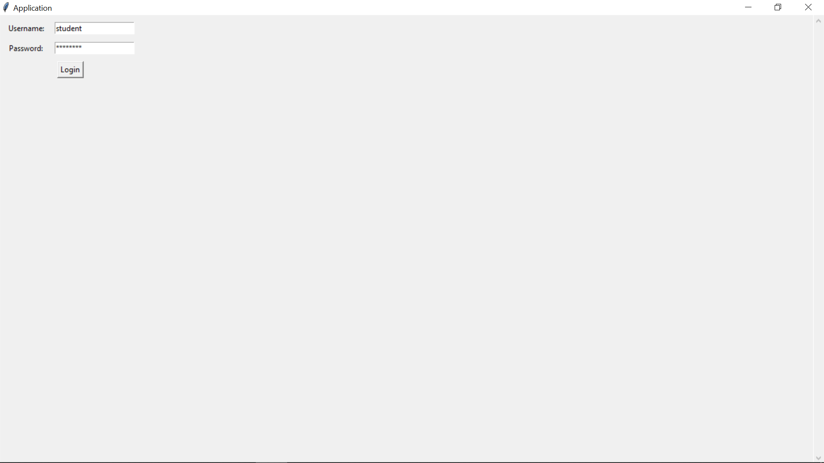

(fig2)

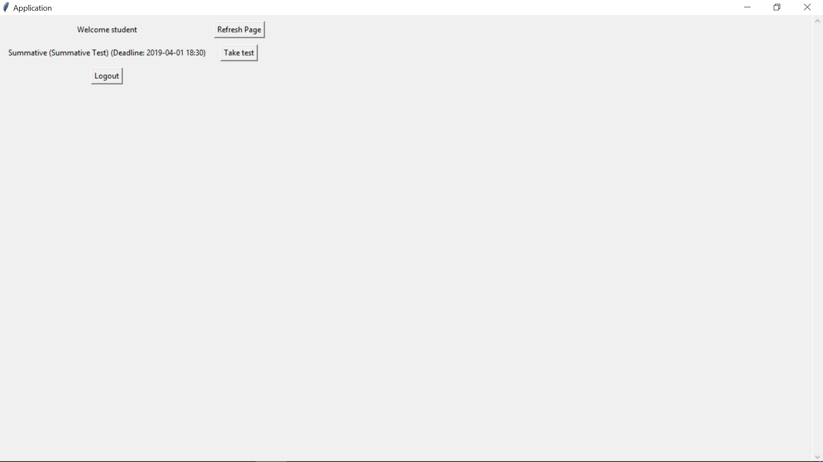

(fig3)

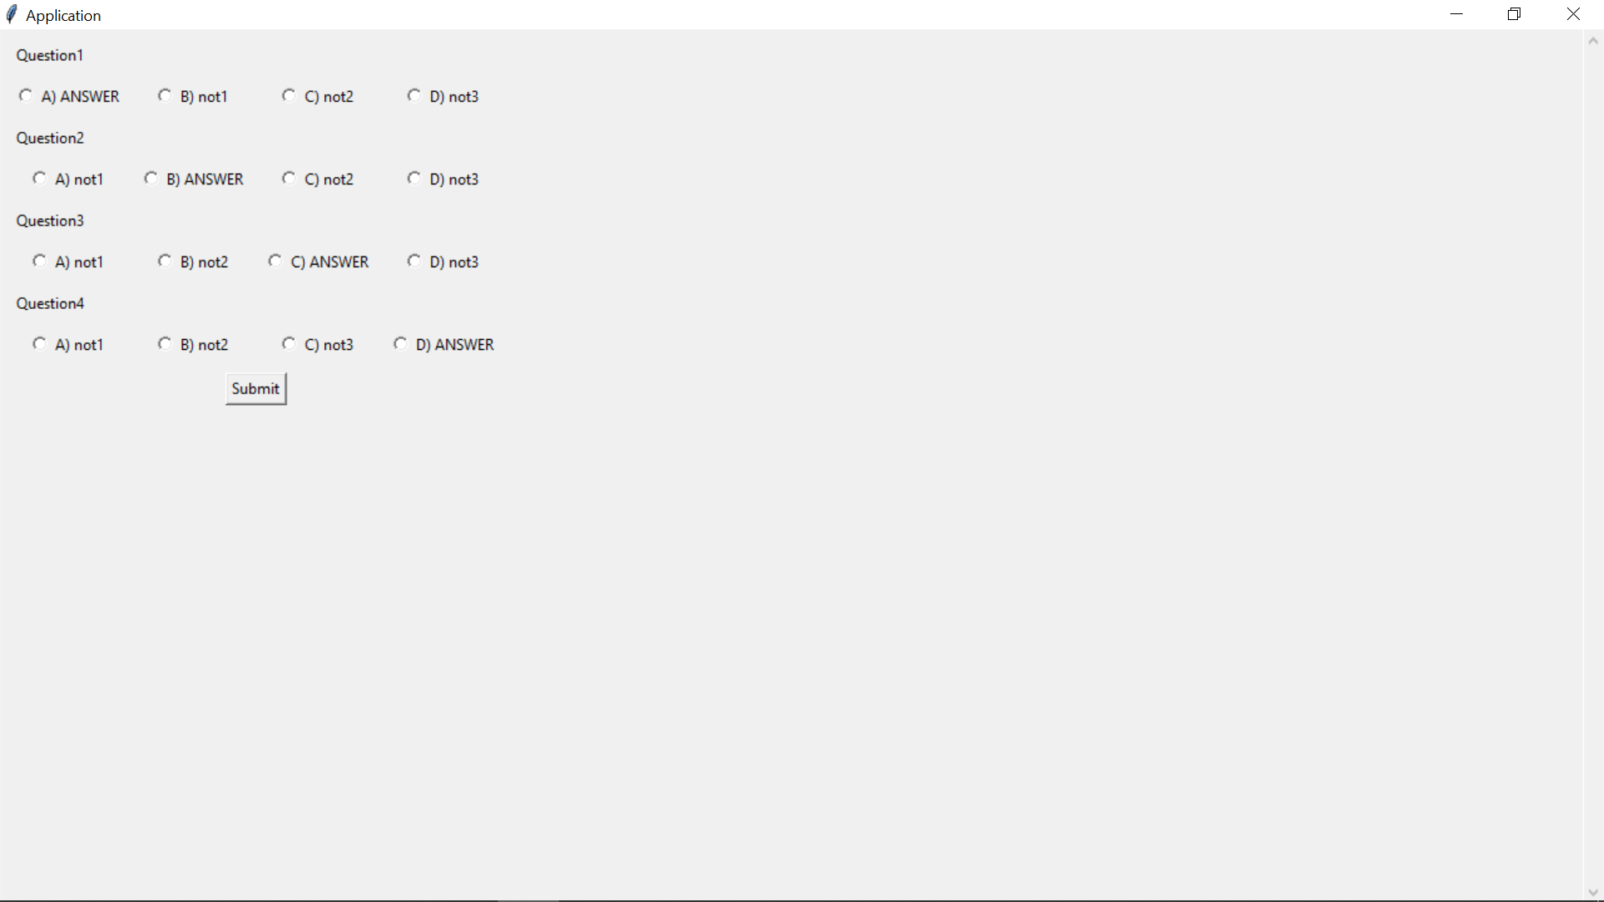

(fig4)

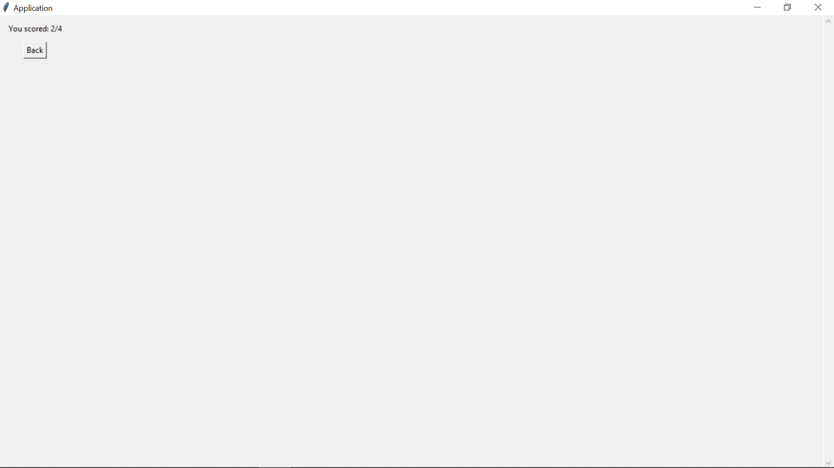

(fig5)

